MySQL Queries
- Total sales analysis:
SELECT month(TRANSACTION_DATE) AS MONTH, ROUND(SUM(unit_price * transaction_qty),2) AS TOTAL_SALES
FROM coffee_shop_sales
group by month(TRANSACTION_DATE);
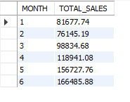
- Month-on-Month Sales Analysis:
SELECT month(TRANSACTION_DATE) AS MONTH, -- month
ROUND(SUM(unit_price * transaction_qty)) AS TOTAL_SALES,
(SUM(unit_price * transaction_qty) - LAG(SUM(unit_price * transaction_qty), 1) -- total sales
OVER(ORDER BY MONTH(TRANSACTION_DATE))) / LAG(SUM(unit_price * transaction_qty), 1) -- month sales difference
OVER(ORDER BY MONTH(TRANSACTION_DATE)) * 100 AS MOM_INCERSE_PRECENTAGE -- division by pervisus month sales
FROM coffee_shop_sales
WHERE MONTH(TRANSACTION_DATE) IN (4,5) -- for apirl and may month
GROUP BY MONTH(TRANSACTION_DATE)
ORDER BY MONTH(TRANSACTION_DATE);
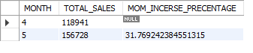
- Total order analysis:
SELECT count(transaction_id) AS TOTAL_ORDERS
FROM coffee_shop_sales
WHERE MONTH(TRANSACTION_DATE) = 3; -- MARCH MONTH
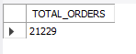
- Month-on-Month Orders Analysis:
SELECT month(TRANSACTION_DATE) AS MONTH, -- month
ROUND(COUNT(transaction_id)) AS TOTAL_ORDERS, -- TOTAL ORDERS
(COUNT(transaction_id) - LAG(COUNT(transaction_id), 1)
OVER(ORDER BY MONTH(TRANSACTION_DATE))) / LAG(COUNT(transaction_id), 1) -- month ORDERS difference
OVER(ORDER BY MONTH(TRANSACTION_DATE)) * 100 AS MOM_INCERSE_PRECENTAGE -- division by pervisus month sales
FROM coffee_shop_sales
WHERE MONTH(TRANSACTION_DATE) IN (4,5) -- for apirl and may month
GROUP BY MONTH(TRANSACTION_DATE)
ORDER BY MONTH(TRANSACTION_DATE);
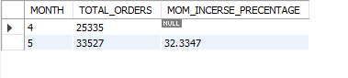
- Total quantity sold analysis:
SELECT SUM(transaction_QTY) AS TOTAL_QUANITY_SOLD
FROM coffee_shop_sales
WHERE MONTH(TRANSACTION_DATE) = 6; -- june MONTH
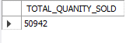
- Month-on-Month Quantity Sold Analysis:
SELECT month(TRANSACTION_DATE) AS MONTH, -- month
ROUND(SUM(transaction_QTY)) AS TOTAL_QUANITY_SOLD, -- TOTAL QUANITY_SOLD
(SUM(transaction_QTY) - LAG(SUM(transaction_QTY), 1)
OVER(ORDER BY MONTH(TRANSACTION_DATE))) / LAG(SUM(transaction_QTY), 1) -- month ORDERS difference
OVER(ORDER BY MONTH(TRANSACTION_DATE)) * 100 AS MOM_INCERSE_PRECENTAGE -- division by pervisus month sales
FROM coffee_shop_sales
WHERE MONTH(TRANSACTION_DATE) IN (4,5) -- for apirl and may month
GROUP BY MONTH(TRANSACTION_DATE)
ORDER BY MONTH(TRANSACTION_DATE);
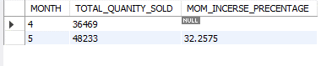
- Total Sales, Total Orders, Total Quantity Sold by date:
SELECT
concat(ROUND(SUM(unit_price * transaction_qty)/1000,1),'K') AS TOTAL_SALES,
concat(ROUND(sum(transaction_qty)/1000,1),'K') AS TOTAL_QTY_SOLD,
concat(ROUND(COUNT(transaction_id)/1000,1),'K') AS TOTAL_ORDERS
FROM coffee_shop_sales
WHERE TRANSACTION_DATE = '2023-03-27';
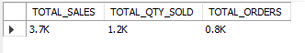
- Sales Analysis by Weekdays and Weekends:
SELECT
CASE WHEN dayofweek(TRANSACTION_DATE) IN (1,7) THEN 'WEEKENDS'
ELSE 'WEEKDAYS'
END AS DAY_TYPE,
concat(ROUND(SUM(unit_price*transaction_qty)/1000,1),'K') AS TOTAL_SALES
FROM coffee_shop_sales
WHERE MONTH(TRANSACTION_DATE) = 5
GROUP BY CASE WHEN dayofweek(TRANSACTION_DATE) IN (1,7) THEN 'WEEKENDS'
ELSE 'WEEKDAYS'
END;
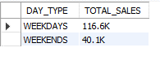
- Sales analysis by store location:
SELECT STORE_LOCATION,
concat(ROUND(SUM(unit_price*transaction_qty)/1000,2),'K') AS TOTAL_SALES
FROM coffee_shop_sales
WHERE MONTH(TRANSACTION_DATE) = 6 -- JUNE MONTH
GROUP BY STORE_LOCATION
ORDER BY SUM(unit_price*transaction_qty) DESC ;
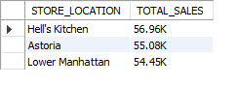
- Average of total sales by month:
SELECT concat(ROUND(AVG(TOTAL_SALES)/1000,1),'K') AS AVG_SALES
FROM
(SELECT SUM(unit_price*transaction_qty) AS TOTAL_SALES
FROM coffee_shop_sales
WHERE MONTH(TRANSACTION_DATE) = 4
GROUP BY TRANSACTION_DATE) AS INNER_QUERY;
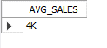
- Daily sales with month selected:
SELECT day(TRANSACTION_DATE) AS DAY_OF_MONTH,
concat(ROUND(SUM(unit_price*transaction_qty)/1000,2),'K') AS TOTAL_SALES
FROM coffee_shop_sales
WHERE MONTH(TRANSACTION_DATE) = 5
group by DAY(TRANSACTION_DATE)
order by DAY(TRANSACTION_DATE);
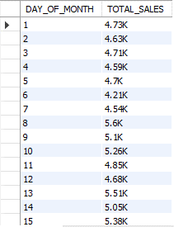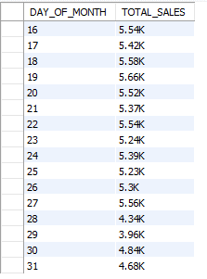

COMPARING DAILY SALES WITH AVERAGE SALES – IF GREATER THAN “ABOVE AVERAGE” and LESSER THAN “BELOW AVERAGE”
SELECT DAY_OF_MONTH,
CASE
WHEN TOTAL_SALES > AVG_SALES THEN 'ABOVE AVERAGE'
WHEN TOTAL_SALES < AVG_SALES THEN 'BELOW AVERAGE'
ELSE 'EQUAL TO AVERAGE'
END AS SALES_STATUS,
TOTAL_SALES
FROM
(SELECT
DAY(TRANSACTION_DATE) AS DAY_OF_MONTH,
SUM(unit_price*transaction_qty) AS TOTAL_SALES,
AVG(SUM(unit_price*transaction_qty)) OVER() AS AVG_SALES
FROM COFFEE_SHOP_SALES
WHERE MONTH(TRANSACTION_DATE) = 5
GROUP BY DAY(TRANSACTION_DATE)) SALES_DATA
ORDER BY DAY_OF_MONTH;
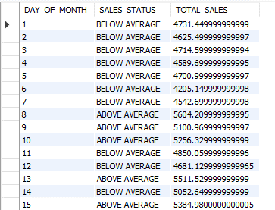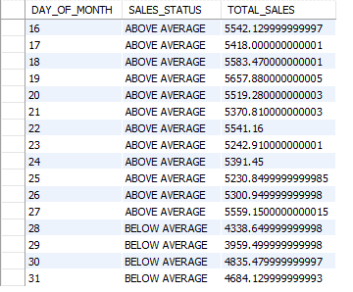
- Sales Analysis by Product Category:
SELECT product_category,
concat(ROUND(SUM(unit_price*transaction_qty)/1000,2),'K') AS TOTAL_SALES
FROM coffee_shop_sales
WHERE MONTH(TRANSACTION_DATE) = 5
GROUP BY product_category
ORDER BY SUM(unit_price*transaction_qty) DESC ;
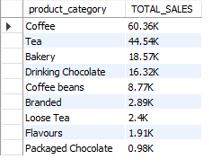
- Top 10 products by sales:
SELECT product_TYPE,
concat(ROUND(SUM(unit_price*transaction_qty)/1000,2),'K') AS TOTAL_SALES
FROM coffee_shop_sales
WHERE MONTH(TRANSACTION_DATE) = 5 AND PRODUCT_CATEGORY = 'COFFEE'
GROUP BY product_TYPE
ORDER BY SUM(unit_price*transaction_qty) DESC
LIMIT 10;
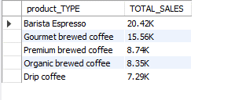
- Total sales, total orders, total quantity sold by days & hours:
SELECT
concat(ROUND(SUM(unit_price*transaction_qty)/1000,2),'K') AS TOTAL_SALES,
SUM(TRANSACTION_QTY) AS TOTAL_QTY_SOLD,
COUNT(*) AS TOTAL_ORDERS
FROM coffee_shop_sales
WHERE MONTH(TRANSACTION_DATE) = 5 -- MAY
AND dayofweek(TRANSACTION_DATE) = 1 -- MONDAY
AND HOUR(TRANSACTION_TIME) = 14; -- HOUR OF 14
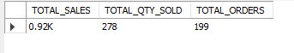
- Total sales for all hours for month of may:
SELECT
HOUR(TRANSACTION_TIME) AS HOURS,
concat(ROUND(SUM(unit_price*transaction_qty)/1000,2),'K') AS TOTAL_SALES
FROM coffee_shop_sales
WHERE MONTH(TRANSACTION_DATE) = 5
GROUP BY HOUR(TRANSACTION_TIME)
ORDER BY HOUR(TRANSACTION_TIME);
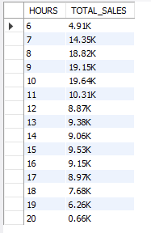

- Sales from monday to sunday for month of may:
SELECT
CASE
WHEN DAYOFWEEK(transaction_date) = 2 THEN 'Monday'
WHEN DAYOFWEEK(transaction_date) = 3 THEN 'Tuesday'
WHEN DAYOFWEEK(transaction_date) = 4 THEN 'Wednesday'
WHEN DAYOFWEEK(transaction_date) = 5 THEN 'Thursday'
WHEN DAYOFWEEK(transaction_date) = 6 THEN 'Friday'
WHEN DAYOFWEEK(transaction_date) = 7 THEN 'Saturday'
ELSE 'Sunday'
END AS Day_of_Week,
ROUND(SUM(unit_price * transaction_qty)) AS Total_Sales
FROM
coffee_shop_sales
WHERE
MONTH(transaction_date) = 5 -- Filter for May (month number 5)
GROUP BY
CASE
WHEN DAYOFWEEK(transaction_date) = 2 THEN 'Monday'
WHEN DAYOFWEEK(transaction_date) = 3 THEN 'Tuesday'
WHEN DAYOFWEEK(transaction_date) = 4 THEN 'Wednesday'
WHEN DAYOFWEEK(transaction_date) = 5 THEN 'Thursday'
WHEN DAYOFWEEK(transaction_date) = 6 THEN 'Friday'
WHEN DAYOFWEEK(transaction_date) = 7 THEN 'Saturday'
ELSE 'Sunday'
END;
